Sample IJTRET Manuscript (Size 24)
First Author¹, Second Author², Third Author^{*3} ( Size 11)
Department& University (Size 10 & italic )
Address Including Country Name
*Corresponding author .author@.alpha-beta.edu (Size 9)

Abstract ( Size 10 & bold &Italic)
Instructions for authors preparing papers for publication in IJTRETJournal is given in this document. Authors can use this document as template to type their text. The authors must follow the instructions given in the document for the papers to be published.

Keywords (Size 10 & Bold) — Include atleast five keywords here, keywords must be separated by comma.

- Introduction (Size 10 & Bold)
(Size 10 & Times New Roman). An electronic copy of a published article can be downloaded from the journal website for reference. For any clarification on paper guidelines, authors may contact the editorial office of the journal. The status of the submitted paper will be communicated to authors through e- mail..
- Page Layout(Size 10 & Bold)
An easy way to comply with the journal paper formatting requirements is to use this document as a template and simply type your text into it.
- Page Layout(Size 10 & Bold & Italic)
Your paper must use a page size corresponding to A4size. The margins must be set as follows:
- Top = 19mm (0.75")
- Bottom = 43mm (1.69")
- Left = Right = 14.32mm (0.56")
The paper must be in two column format with a space of 4.22mm (0.17") between columns.
Recommeded page layout is given in Table 1
- Page Style(Size 10 & Bold)
All paragraphs must be indented. All paragraphs must be left and right justified.
- Text Font of Entire Document(Size 10 & Bold & Italic)
The entire document should be in Times New Roman or Times font.However other font types may be used if needed for special purposes.
Recommended font sizes are shown in Table 2.
- Title and Author Details(Size 10 & Bold & Italic)
Title must be in 24 pt Regular font. Author name must be in 11 pt Regular font. Author affiliation must be in 10 pt Italic. Email address must be in 9 pt Courier Regular font.

- TABLE i
Journal PAPER FORMAT(SIZE 8)
Margin | Top | Bottom | Left | Right
 | 1’’ | 1’’ | 0.56 | 0.56
Page layout | Header |  | Footer
 | 0.79’’ |  | 0.79’’

- TABLE II
Font Sizes for JOURNAL Papers(Size 8)
Font Size | Appearance (in Time New Roman or Times)
 | Regular | Bold | Italic
8 | table caption (in Small Caps),  figure caption,  reference item |  | reference item
9 | author email address ,  details in table cell | Text in abstract | abstract heading (Bold italic )
10 | level-1 heading (in Small Caps),  paragraph |  | level-2 heading,  level-3 heading,  author affiliation
11 | author name
24 | title

All title and author details must be in single-column format and must be centered.
Author details must not show any academic title (e.g. Dr.) or any membership of any professional organization (e.g. Member ISTE).
To avoid confusion, the family name must be written as the last part of each author name .
Each affiliation must include, at the very least, the name of the company and the name of the country where the author is based (e.g. Causal Productions Pty Ltd, Australia).
Email address is compulsory for the corresponding author.

- Section Headings(Size 10 & Bold & Italic)
No more than 3 levels of headings should be used. All headings must be in 10pt font. Every word in a heading must be capitalized except for short minor words as listed in Section III-B.
- Level-1 Heading:(Size 10 & Bold & Italic) A level-1 heading must be in Small Caps, centered and numbered using uppercase Roman numerals. For example, see heading “III. Page Style” of this document. The two level-1 headings which must not be numbered are “Acknowledgment” and “References”.
- Level-2 Heading:(Size 10 & Bold & Italic)A level-2 heading must be in Italic, left-justified and numbered using an uppercase alphabetic letter followed by a period. For example, see heading “C. Section Headings” above.
- Level-3 Heading:(Size 10 & Bold & Italic)A level-3 heading must be indented, in Italic and numbered with an Arabic numeral followed by a right parenthesis. The level-3 heading must end with a colon. The body of the level-3 section immediately follows the level-3 heading in the same paragraph. For example, this paragraph begins with a level-3 heading.
- Figures and Tables(Size 10 & Bold & Italic)
(Size 10 & Normal)Figures and tables must be centered in the column. Large figures and tables may span across both columns. Any table or figure that takes up more than 1 column width must be positioned either at the top or at the bottom of the page.
Graphics may be full color. All colors will be retained on the CDROM. Graphics must not use stipple fill patterns because they may not be reproduced properly. Please use only SOLID FILLcolors which contrast well both on screen and on a black-and-white hardcopy, as shown in Fig. 1.

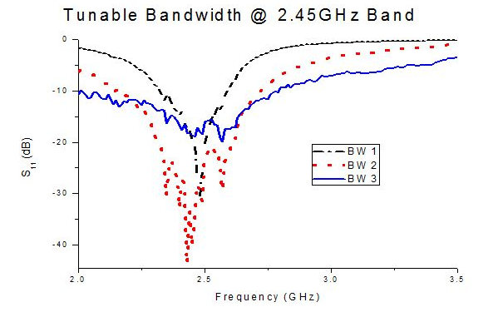Fig. 1 A sample line graph using colors which contrast well both on screen and on a black-and-white hardcopy

Figure can be extended to both the columns. Fig. 2 shows an example of a figure extended to both columns.

- Figure Captions(Size 10 & Bold & Italic)

Figures must be numbered using Arabic numerals. Figure captions must be in 8 pt Regular font. Captions with figure numbers must be typed below figures, as shown in Fig. 1.

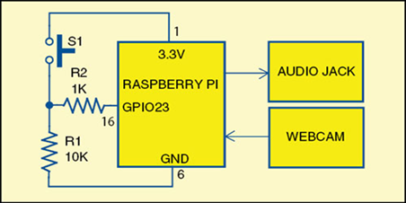

Fig 2: If necessary, the images can be extended both columns

- Table Captions(Size 10 & Bold & Italic)
Tables must be numbered using uppercase Roman numerals. Table captions must be centred and in 8 pt Regular font with Small Caps. Captions with table numbers must be placed before(above) their associated tables, as shown in Table 1.

- Conclusion(Size 10 & Bold)

A conclusion section must be included and should indicate clearly the advantages, limitations, and possible applications of the paper. Although a conclusion may review the main points of the paper, do not replicate the abstract as the conclusion. A conclusion might elaborate on the importance of the work or suggest applications and extensions.

Acknowledgment(Size 10 & Bold)
The heading of the Acknowledgment section and the References section must not be numbered.
Authors wish to acknowledge Mr.David and other contributors for carrying out this reseaech work and the preaparation of this manuscript. Authirs also wish to acknowledge

References (Size 10 & Bold)

This heading is not assigned a number.

A reference list MUST be included using the following information as a guide. Only cited text references are included. Each reference is referred to in the text by a number enclosed in a square bracket (i.e., [3]). References must be numbered and ordered according to where they are first mentioned in the paper, NOT alphabetically.

All reference items must be in 8 pt font,regular and Italic styles to distinguish different fields as shown in the References section.Number the reference items consecutively in square brackets (e.g. [1]). Multiple references are each numbered with separate brackets (e.g. [2], [3], [4]–[6]).
Examples fo references from book[1],chapter in a book [2],journal article [3],paper in conference proceedings [4],website [5],master’s thesis [6] are given below

[1]R.E. Moore, Interval analysis (Englewood Cliffs,
NJ: Prentice-Hall, 1966).

[2]P.O. Bishop, Neurophysiology of binocular vision, in J.Houseman (Ed.), Handbook of physiology, 4 (New York: Springer-Verlag, 1970 342-366.

[3]M Ozaki, Y. Adachi, Y. Iwahori, N. Ishii, Application of fuzzy theory to writer recognition of Chinese characters, International Journal of Modelling and Simulation, 18(2), 1998, 112-116.

[4]Shah H, Shah A. “Optical character recognition of Gujarati numerical”. Proc. Int. Conference on Signals, Systems and Automation. 2009, 49–53.

[5].http://www.explainthatstuff.com/how-ocr-works.html

[6]D.S. Chan, Theory and implementation of multidimensional discrete systems for signal processing, doctoral diss., Massachusetts Institute of Technology, Cambridge, MA, 1978.

Biographies and Photographs
Short biographies (120-150 words) should be provided that detail the authors’ education and work histories as well as their research interests. The authors’ names are italicized. Small (3.5 X 4.8 cm), black-and-white pictures/digitized images of the authors can be included.

